**Practical NO.**

**//Perform the Steps of Create Main Menu inDrupal**

Step 1 - Login in WordPress Administrator (Node)

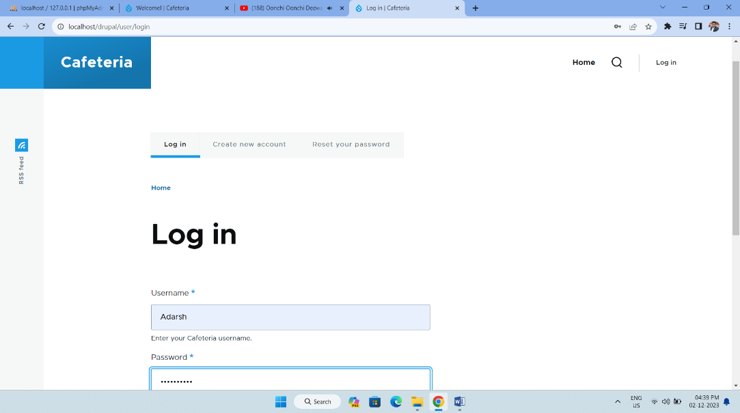

Step 2 - Select Structure option

Structure > Menus > Add Menu

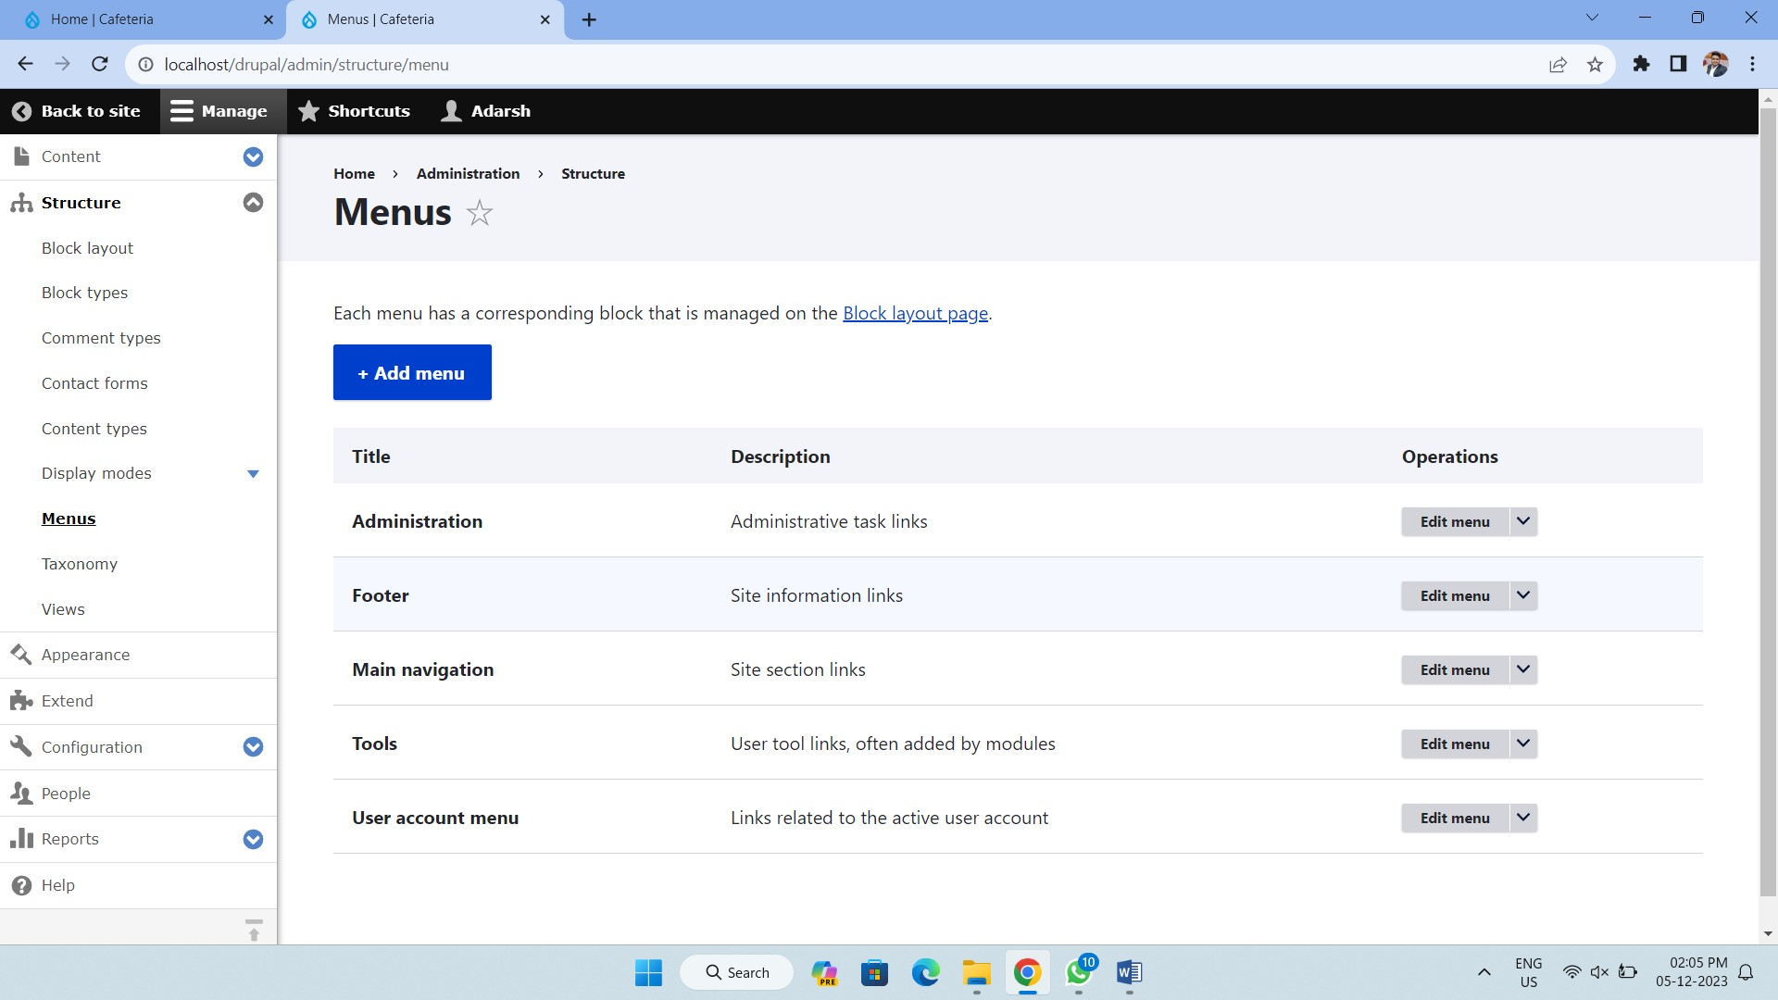

Step 3 - The Add Menu form appears.

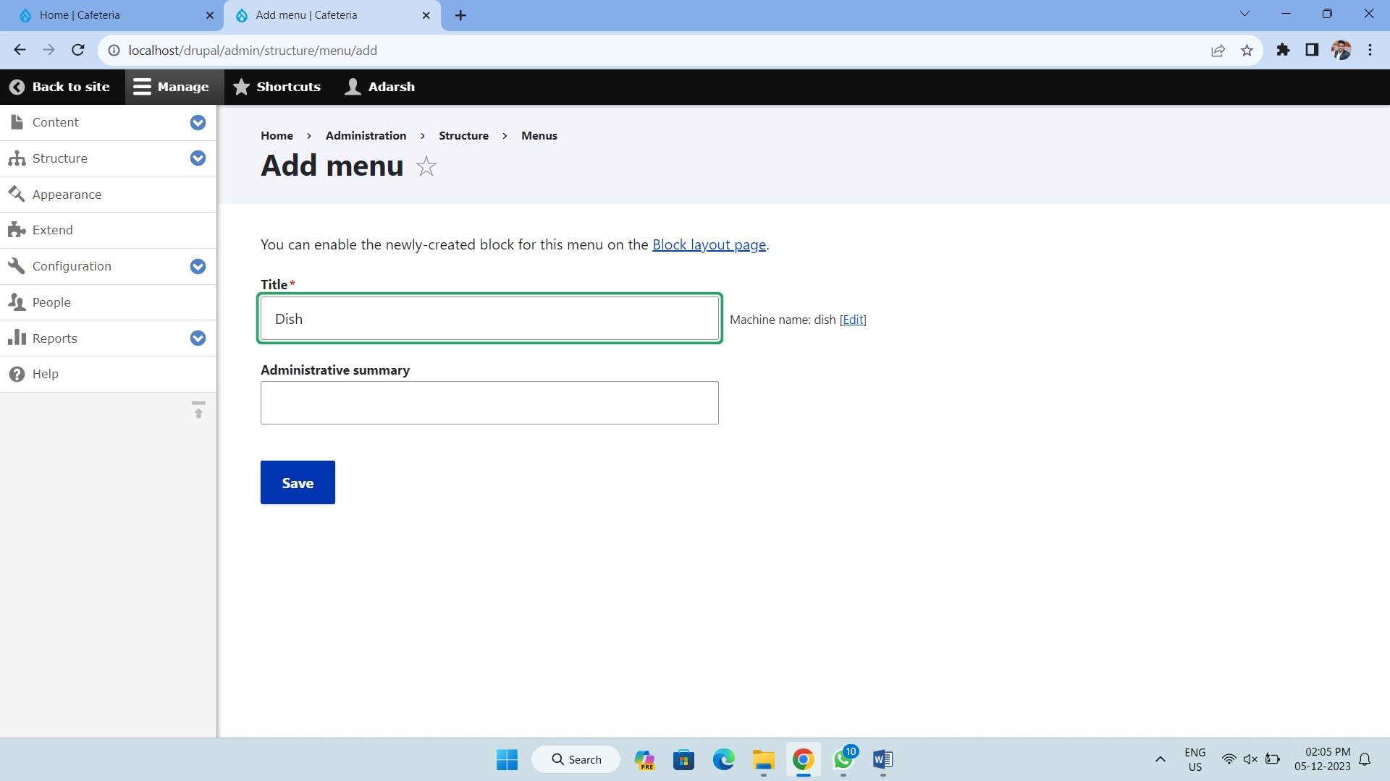

Step 4 - To add new link, you just click on add Link.

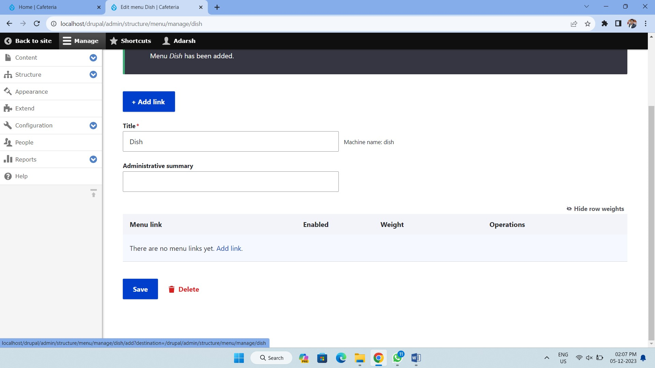

Step 5 - Front End (Content Created, Modified, Published)

